WIX

https://editor.wix.com/html/editor/web/renderer/edit/c3201d46-3eef-4cea-a863-599141f1aadf?metaSiteId=91c34d57-f9dc-41c6-a78d-d5971bdde54a

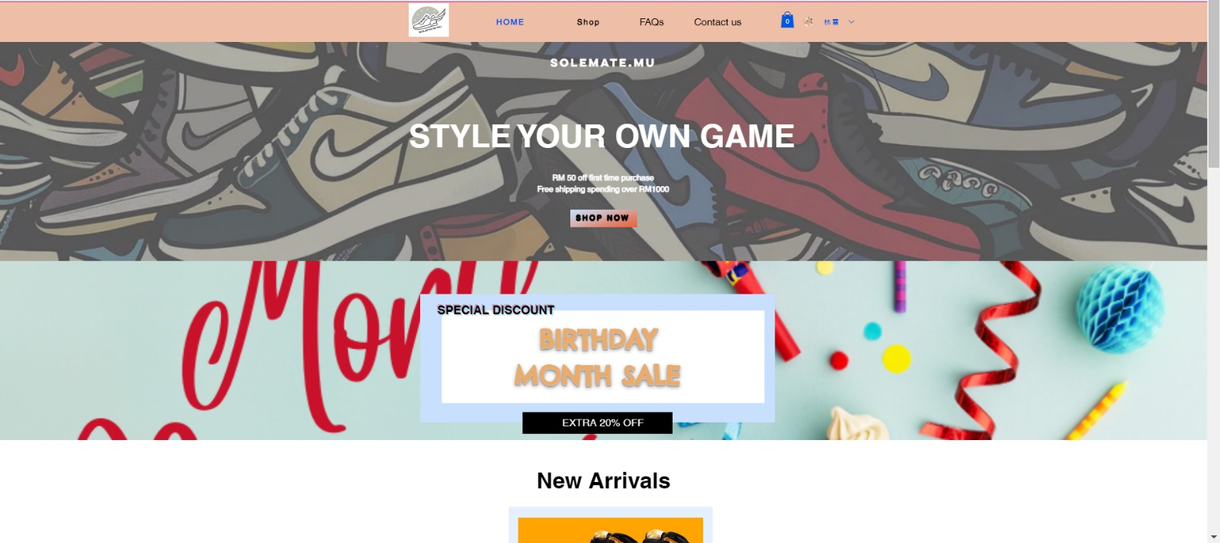

Figure 1: The home page of WIX website

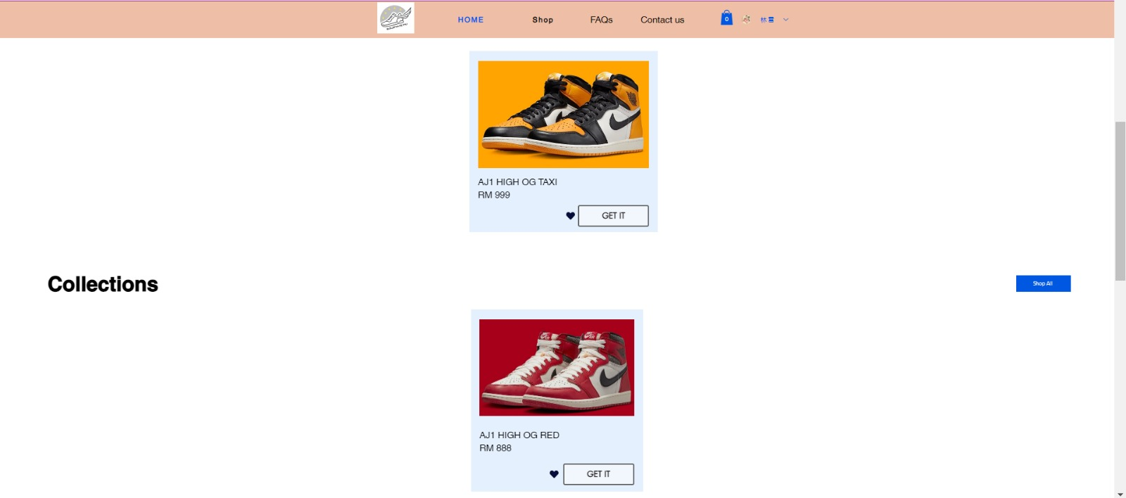

Figure 2: The New Arrivals and Collections of the products

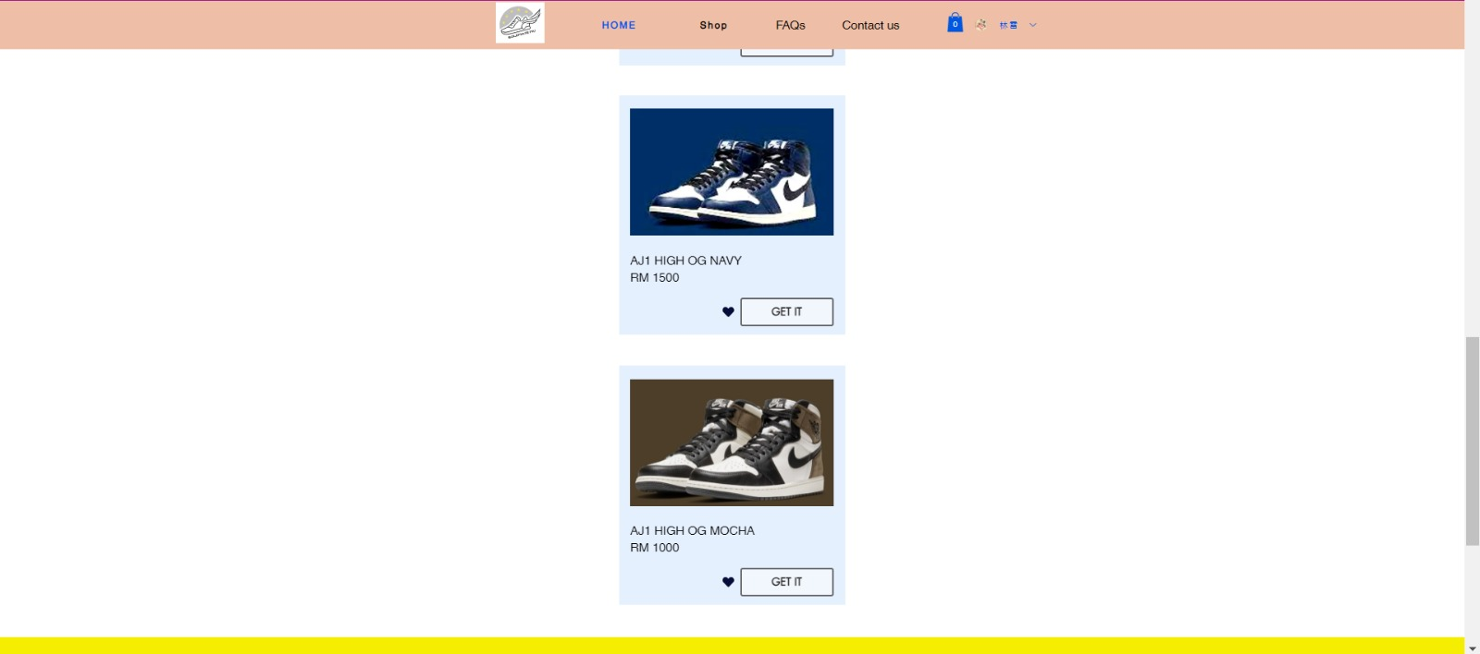

Figure 3: The Collections Sneakers

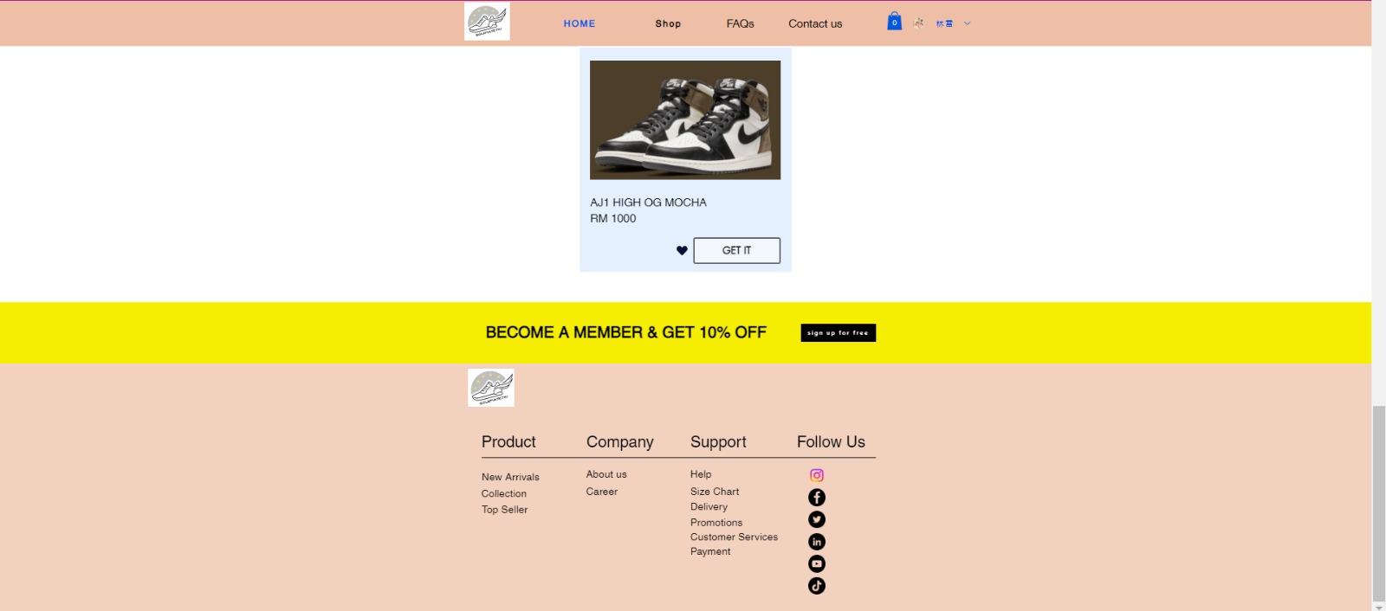

Figure 4: The Last page of the main page

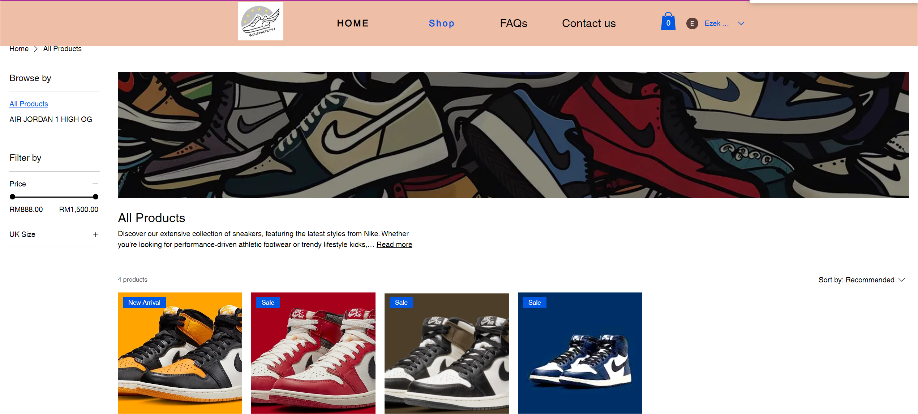

Figure 5: The first part of category page

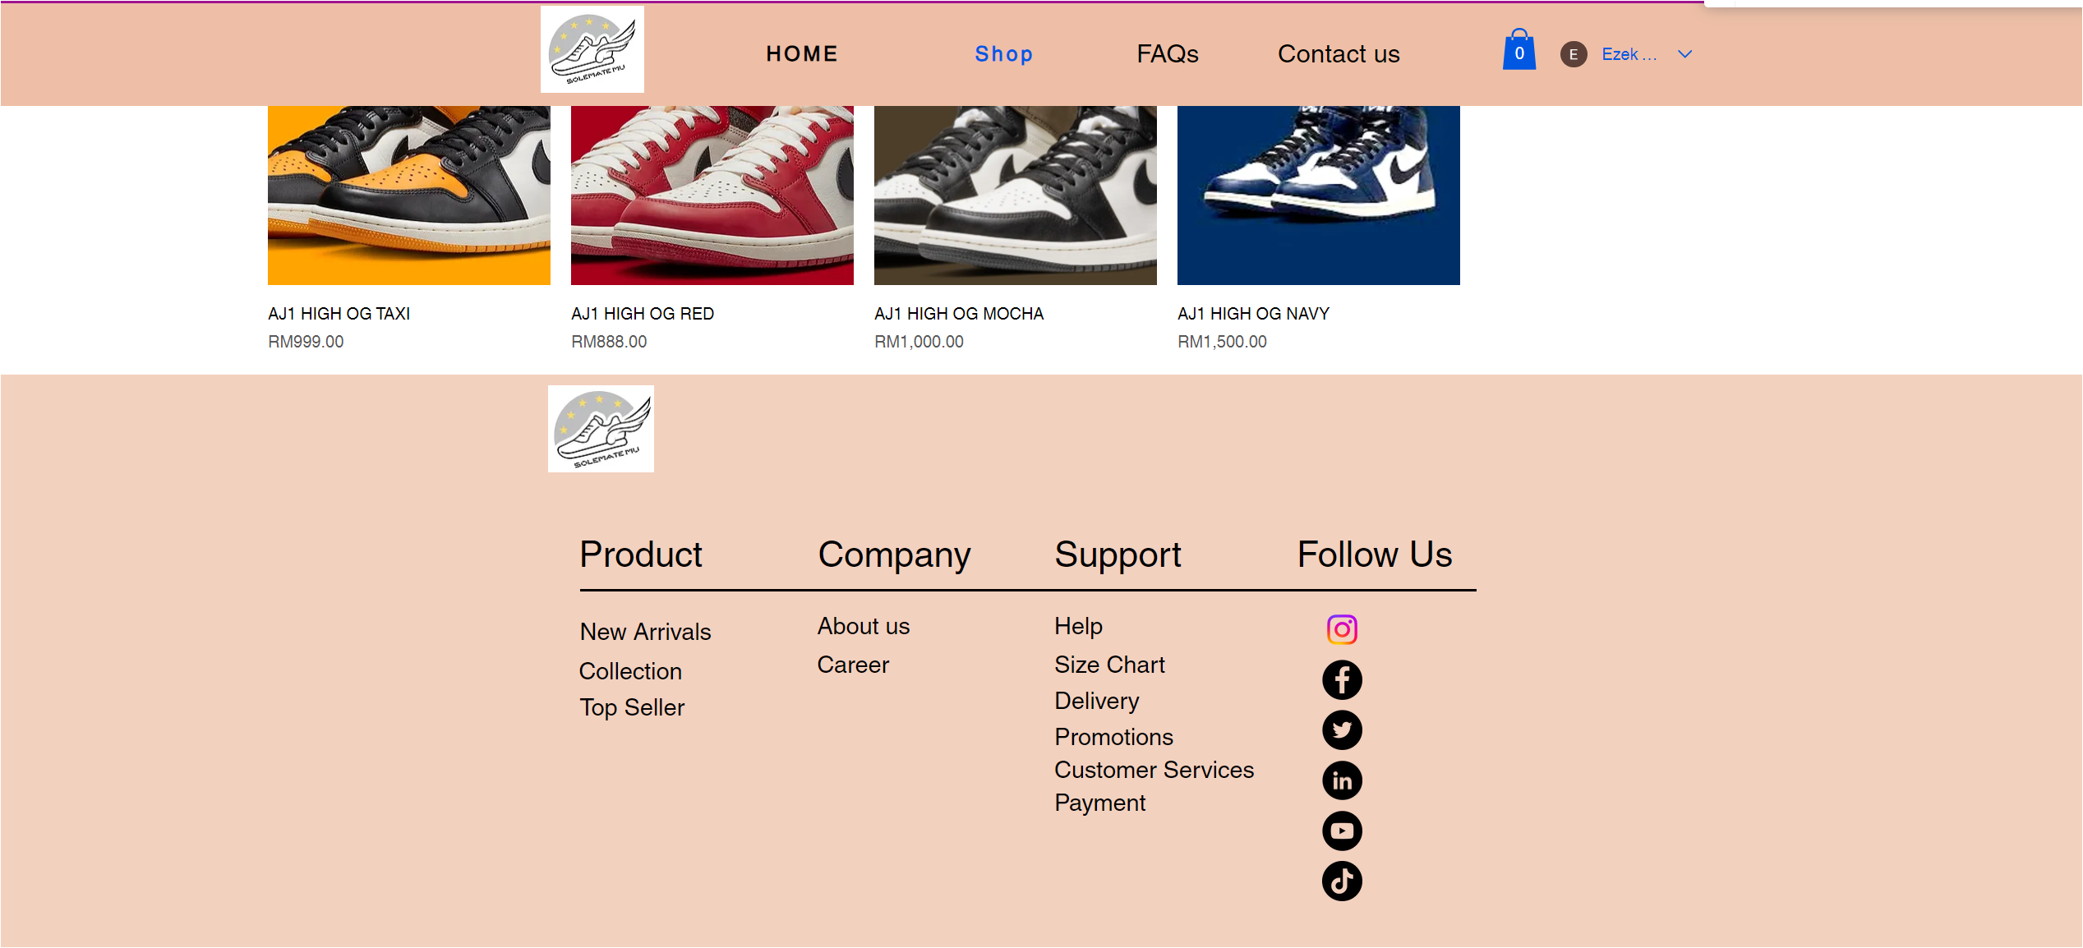

Figure 6: The last part of the category page

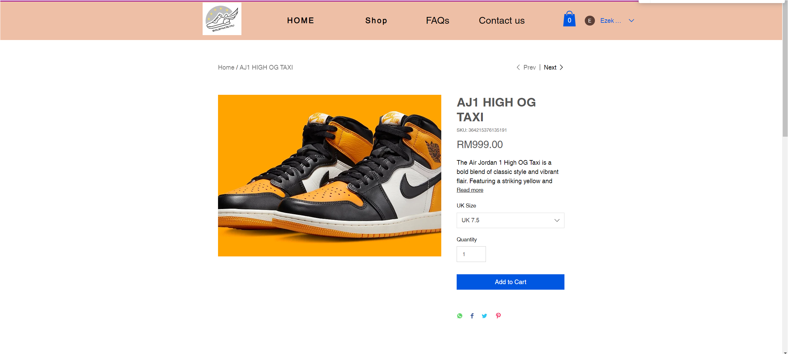

Figure 7: The First part of the AJ1 HIGH OG TAXI product page

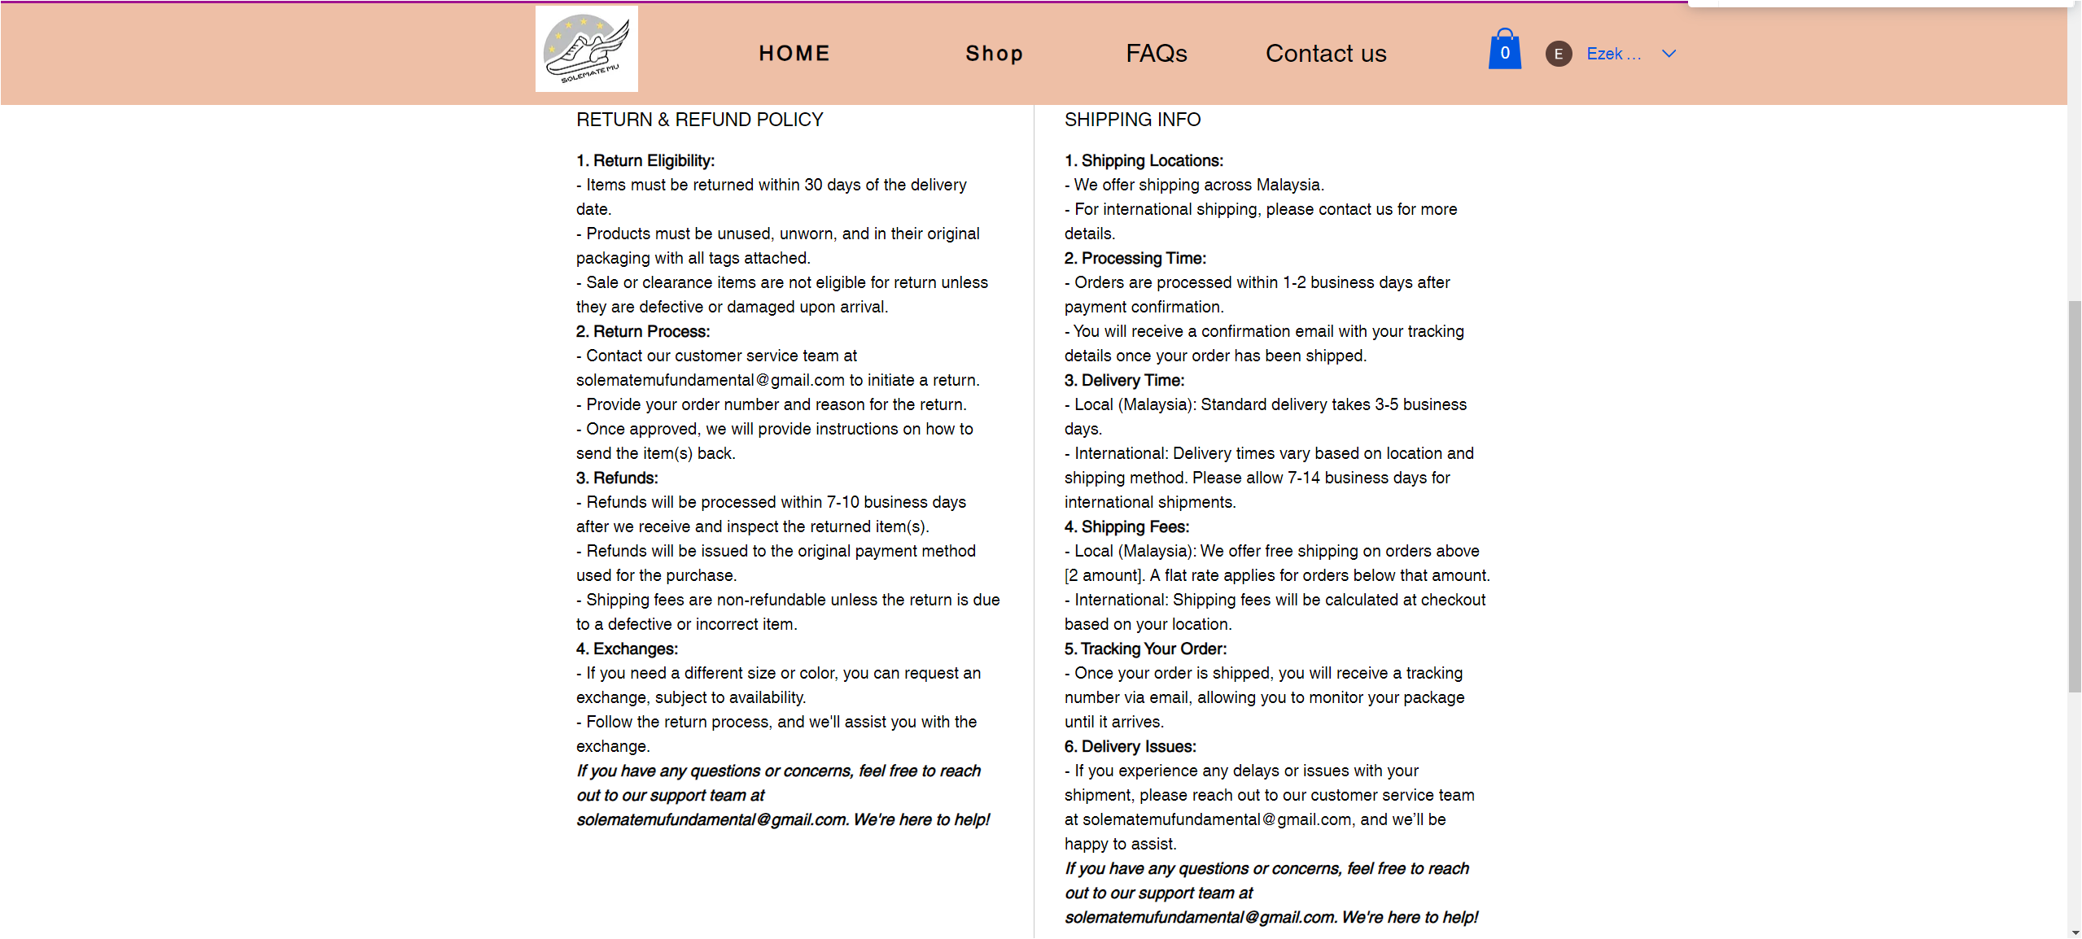

Figure 8: The second part of the AJ1 HIGH OG TAXI product page

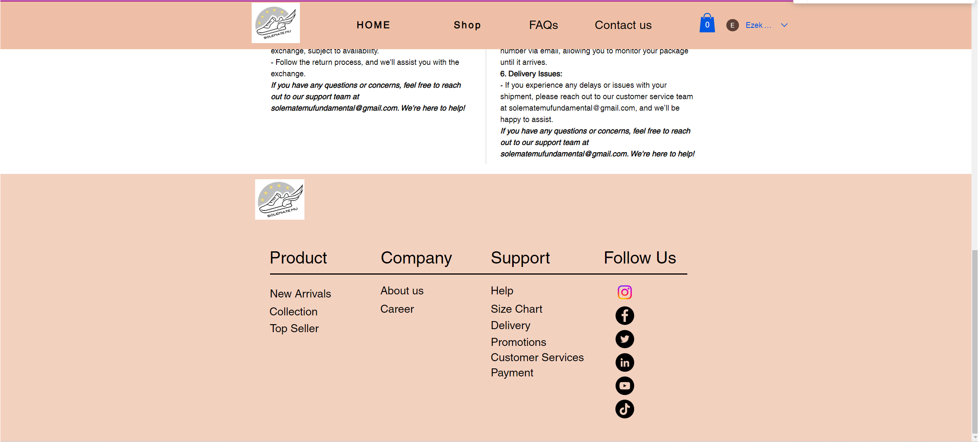

Figure 9: The last part of the AJ1 HIGH OG TAXI product page

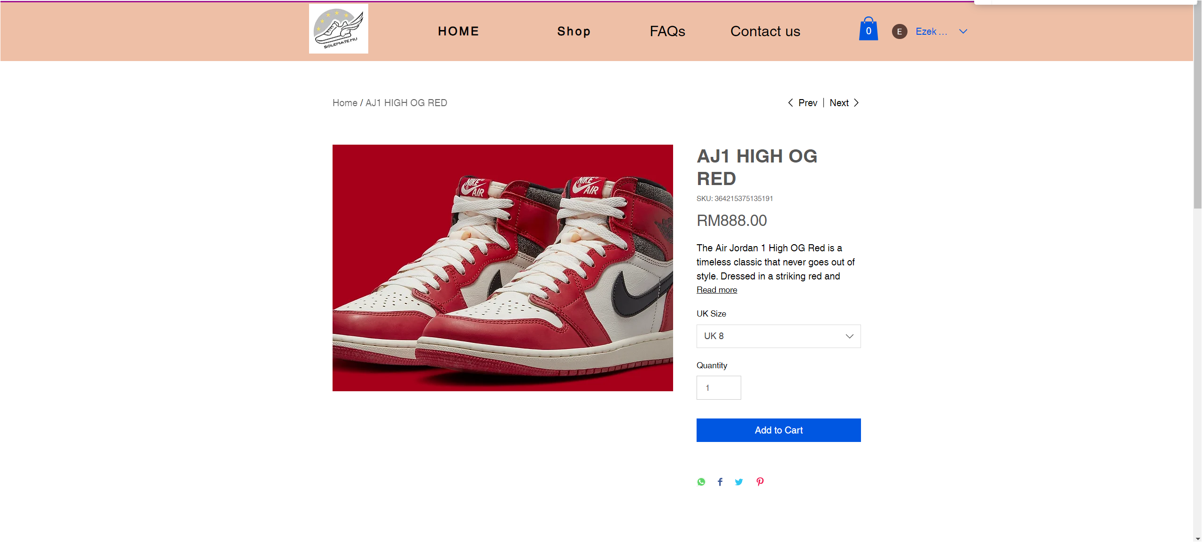

Figure 10: The first part of the AJ1 HIGH OG RED product page

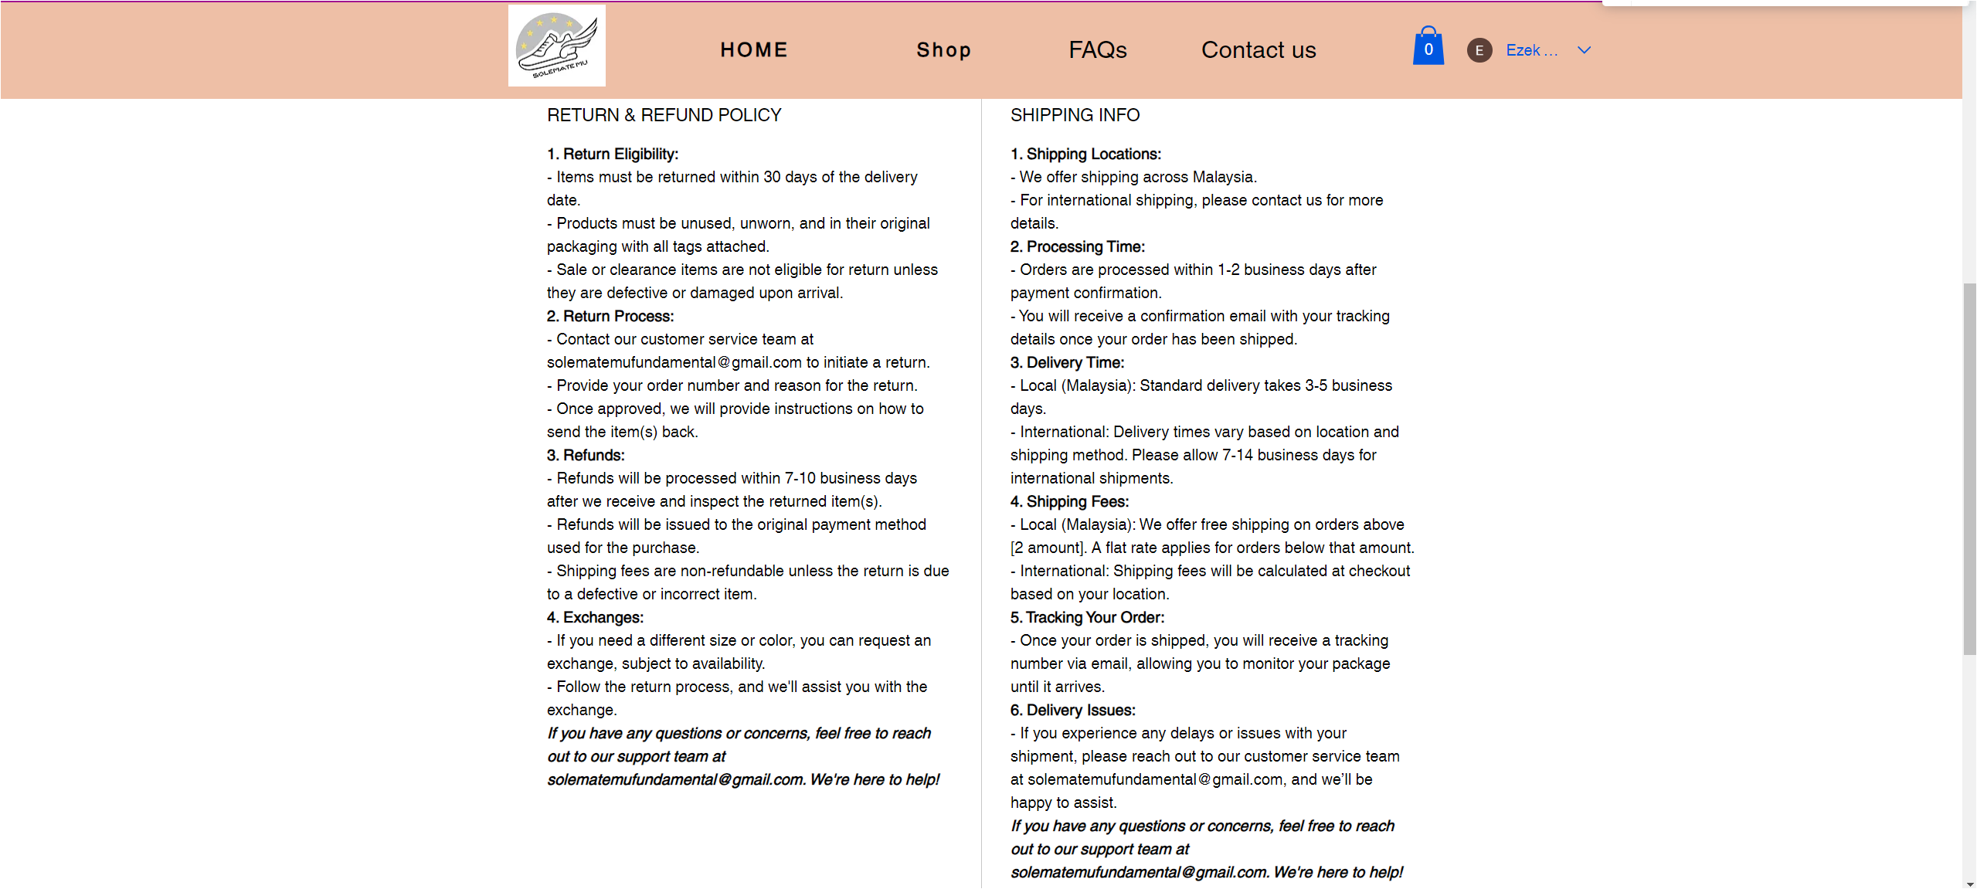

Figure 11: The second part of the AJ1 HIGH OG RED product page

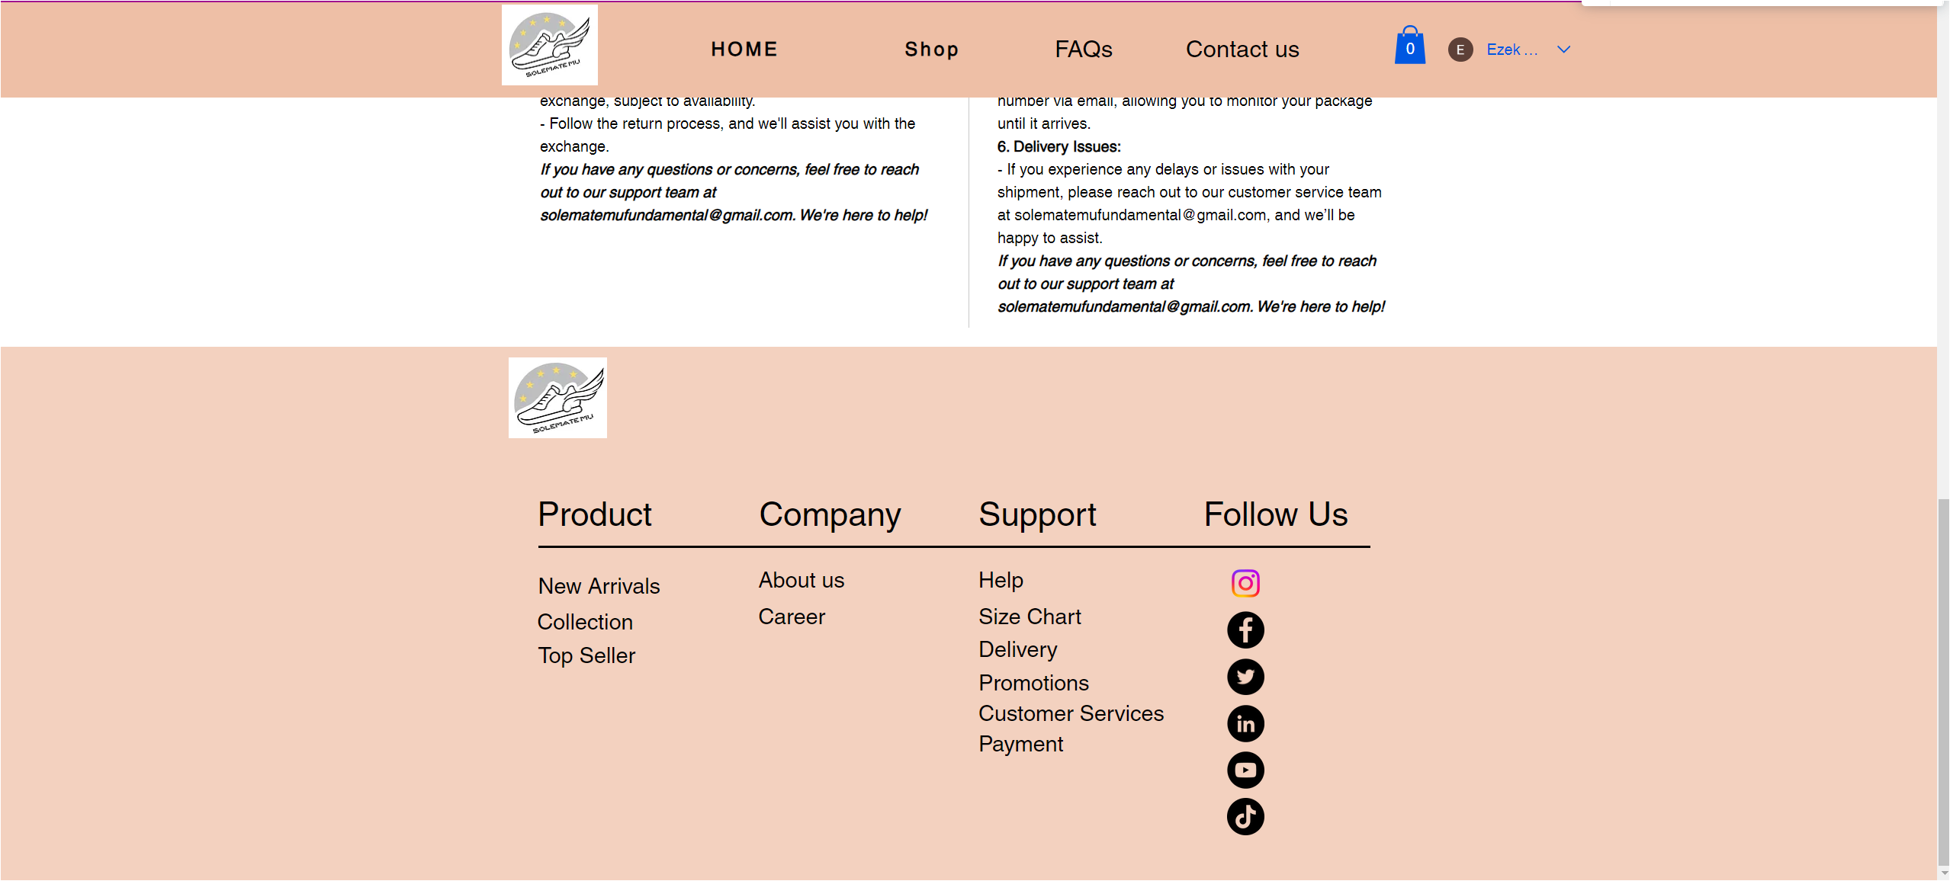

Figure 12: The last part of the AJ1 HIGH OG RED product page

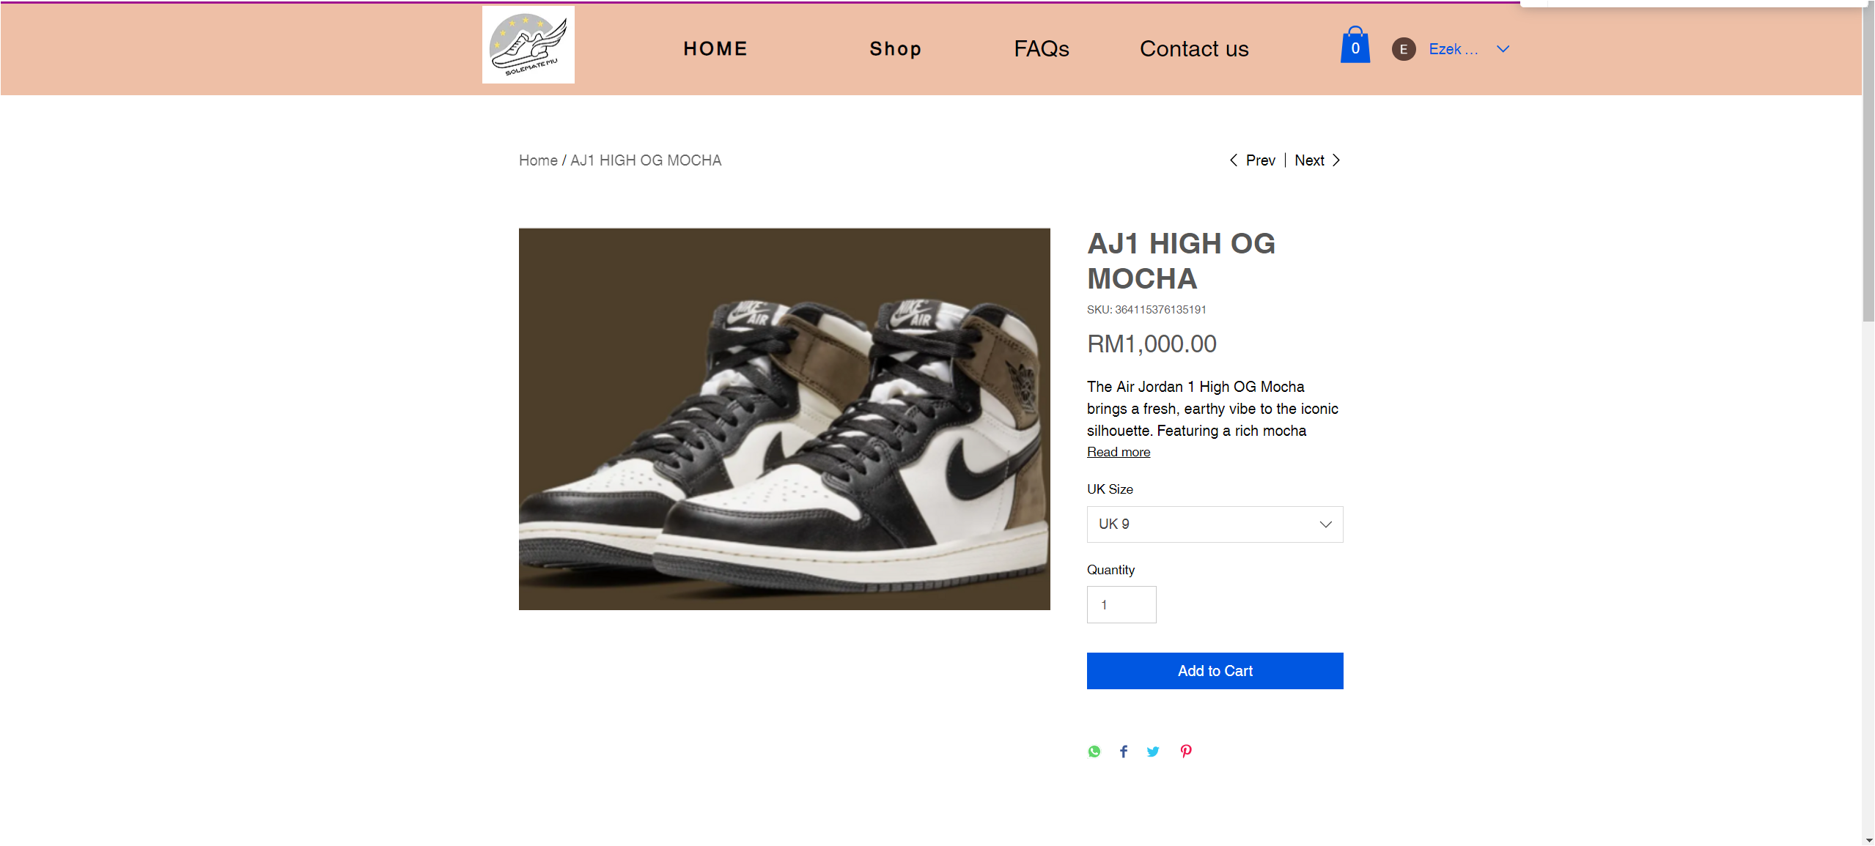

Figure 13: The first part of the AJ1 HIGH OG MOCHA product page

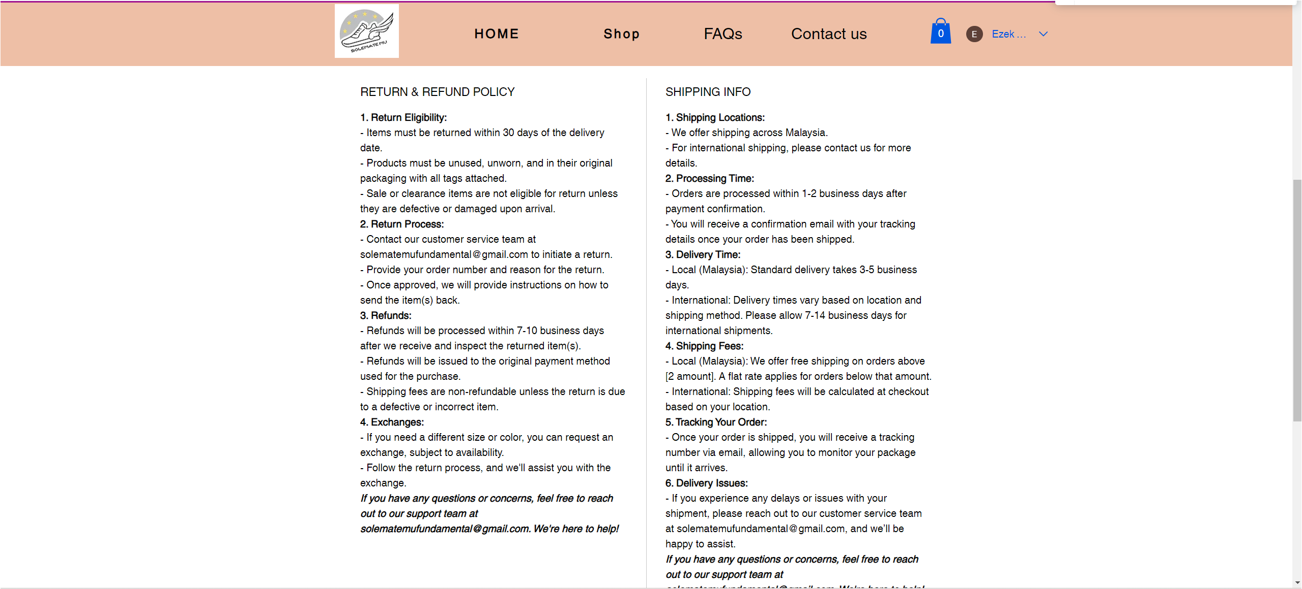

Figure 14: The second part of the AJ1 HIGH OG MOCHA product page

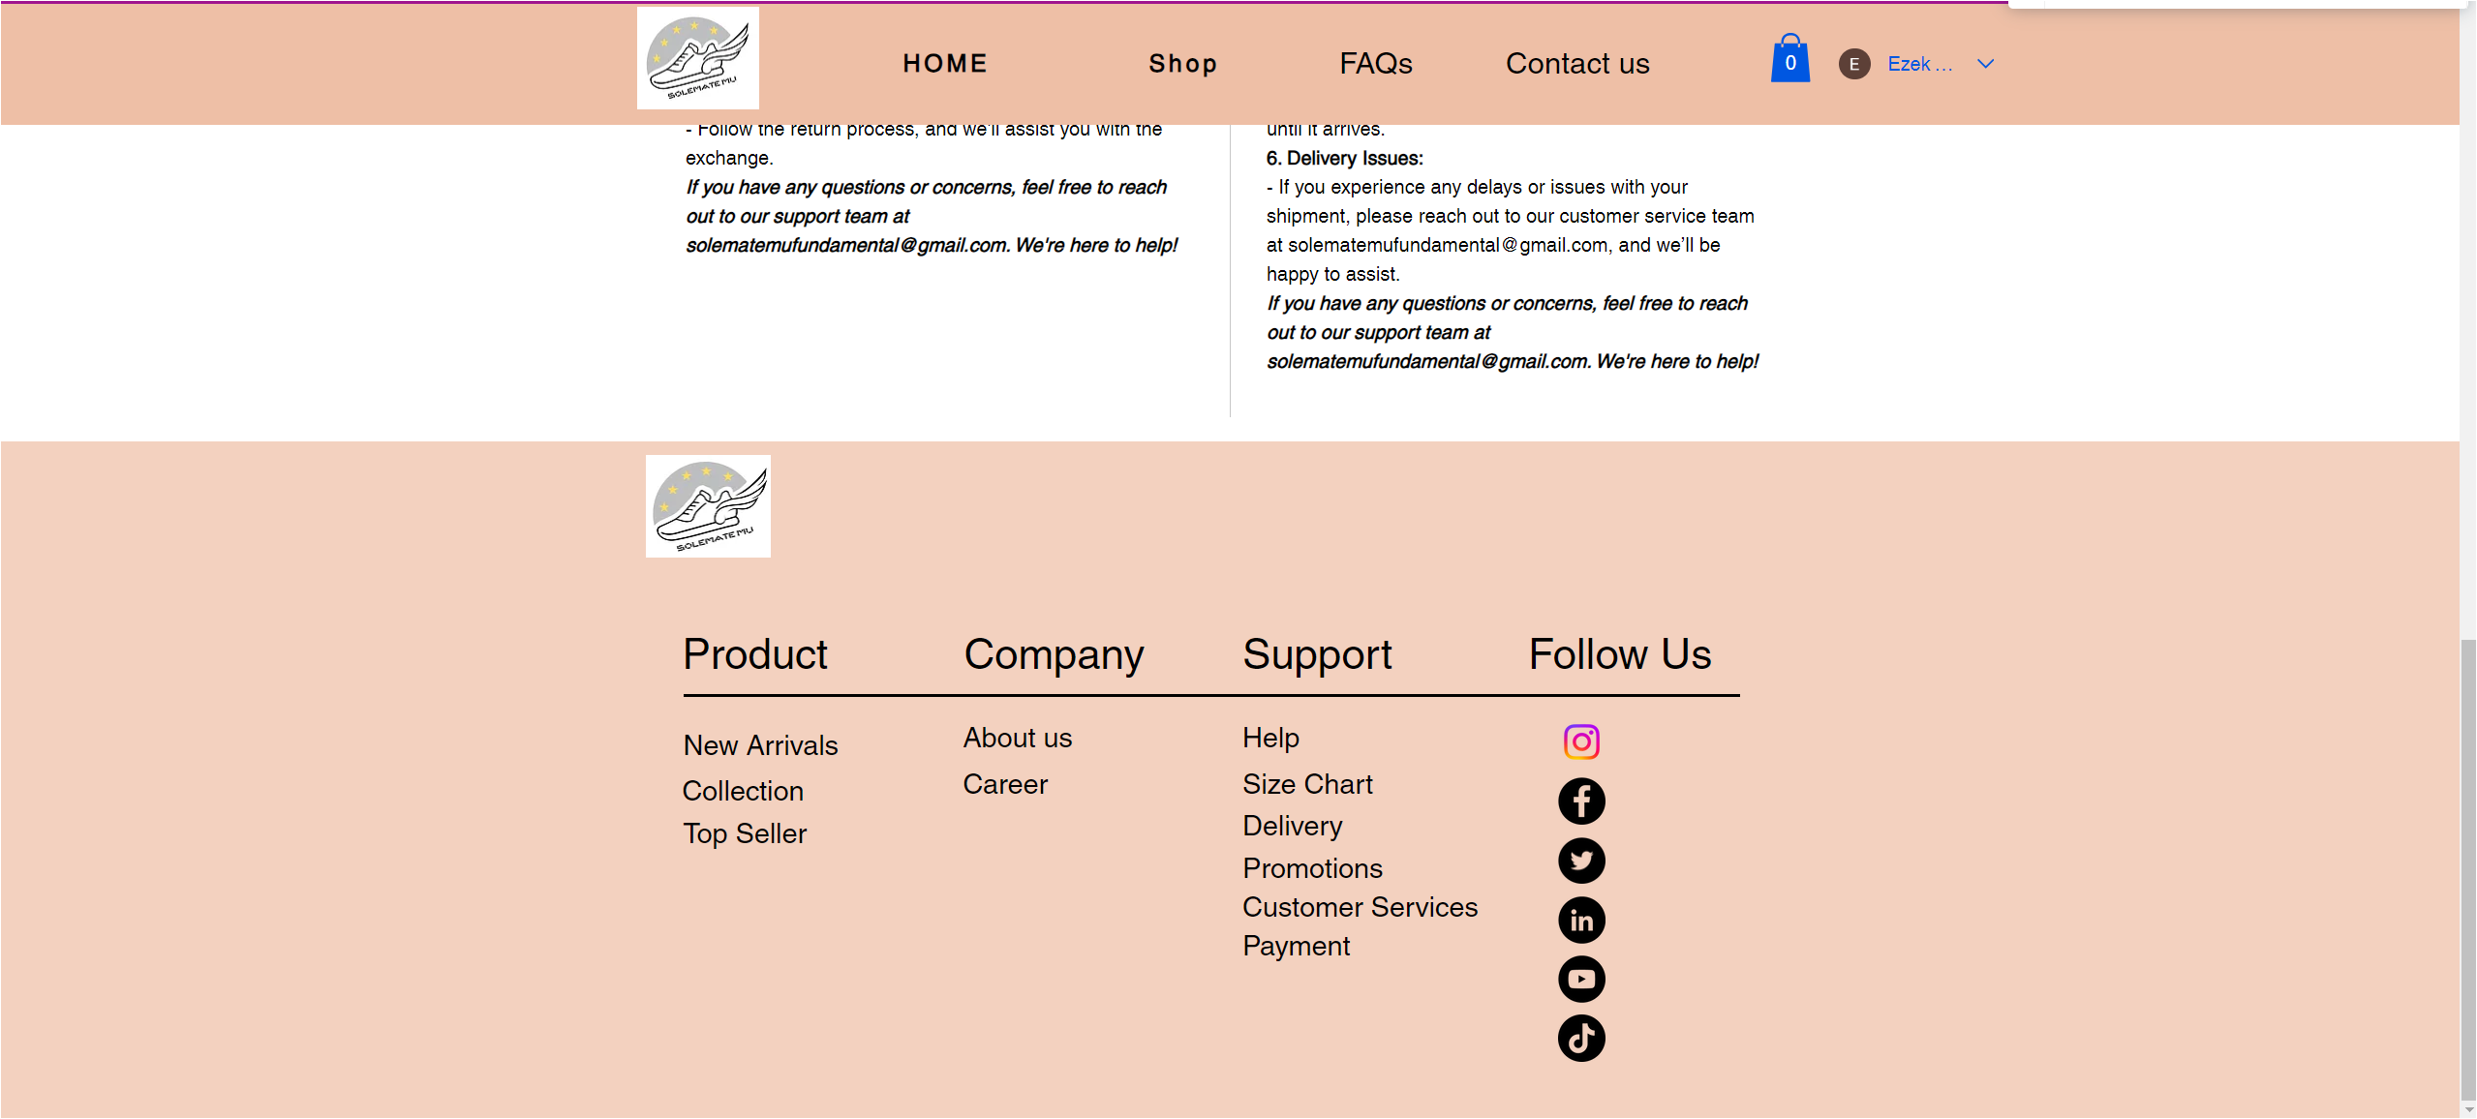

Figure 15: The last part of the AJ1 HIGH OG MOCHA product page

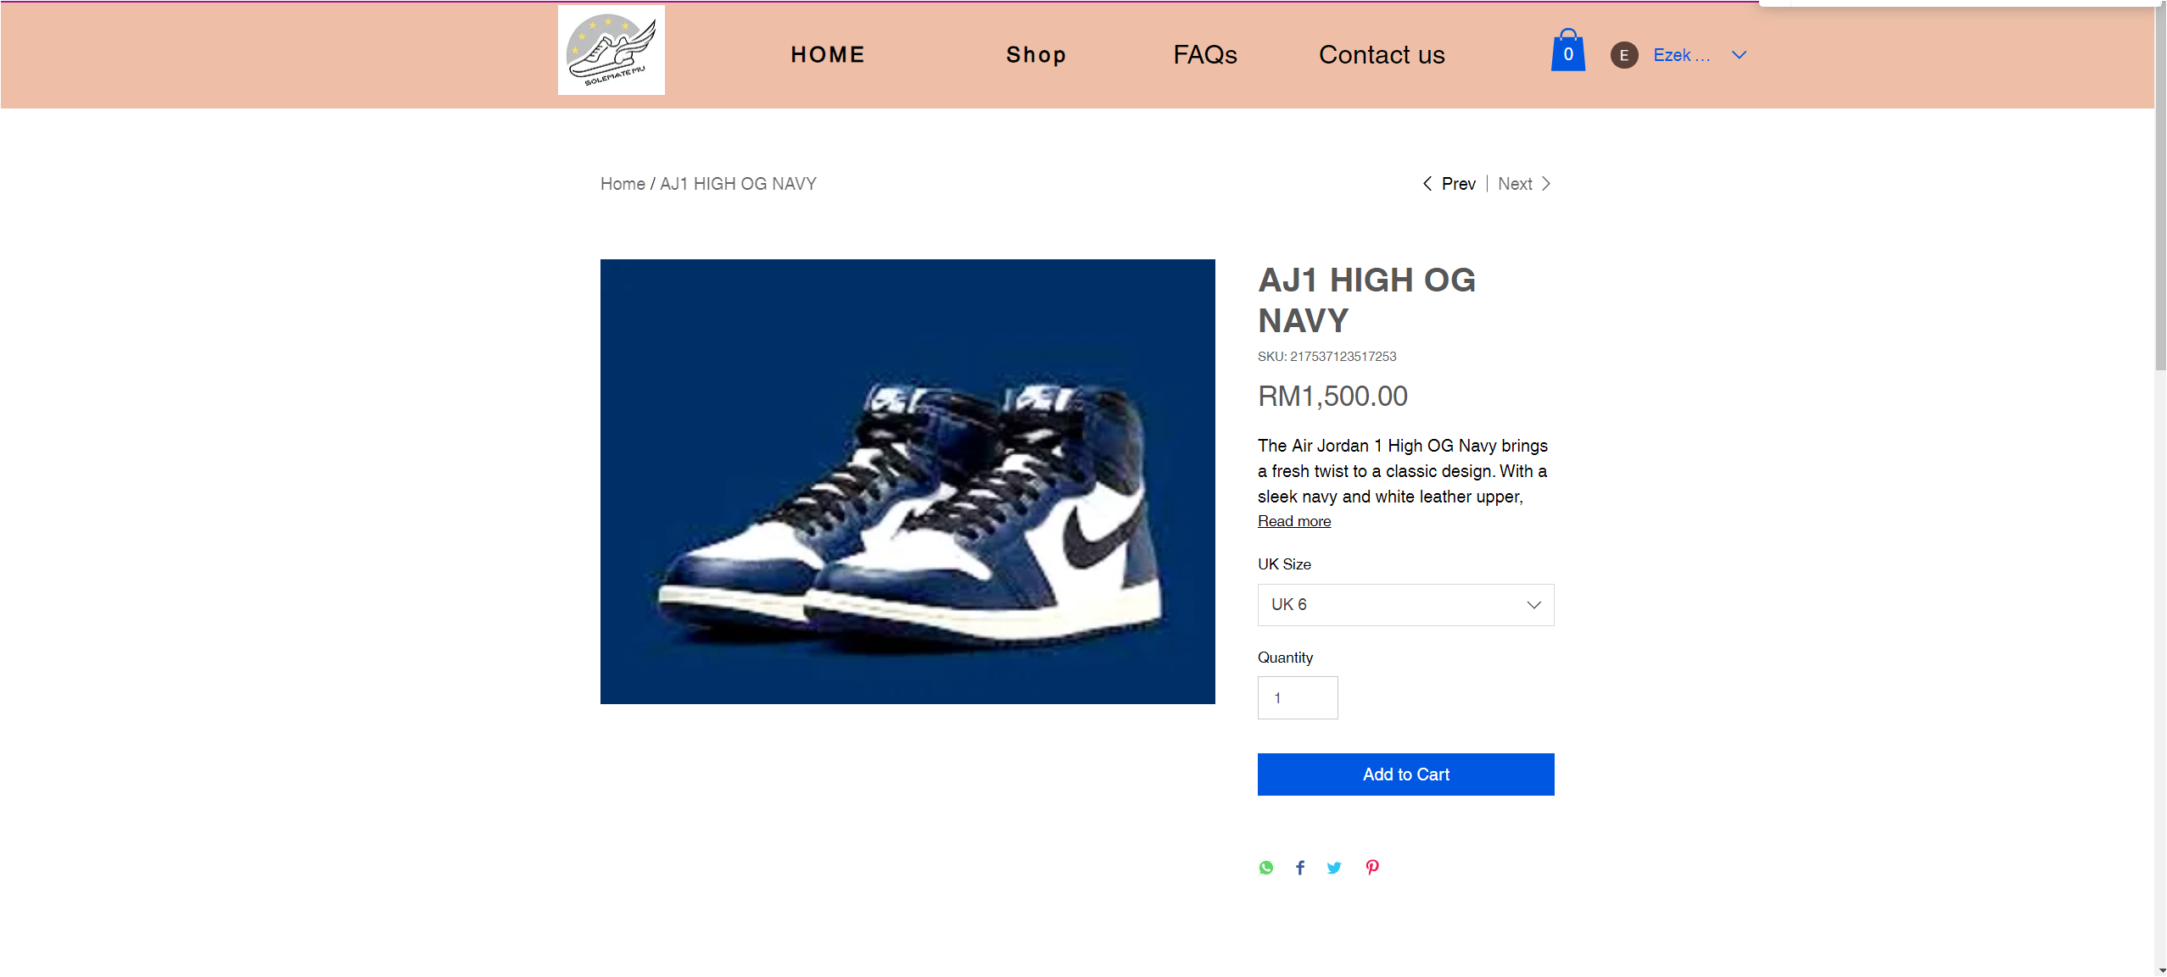

Figure 16: The first part of the AJ1 HIGH OG NAVY product page

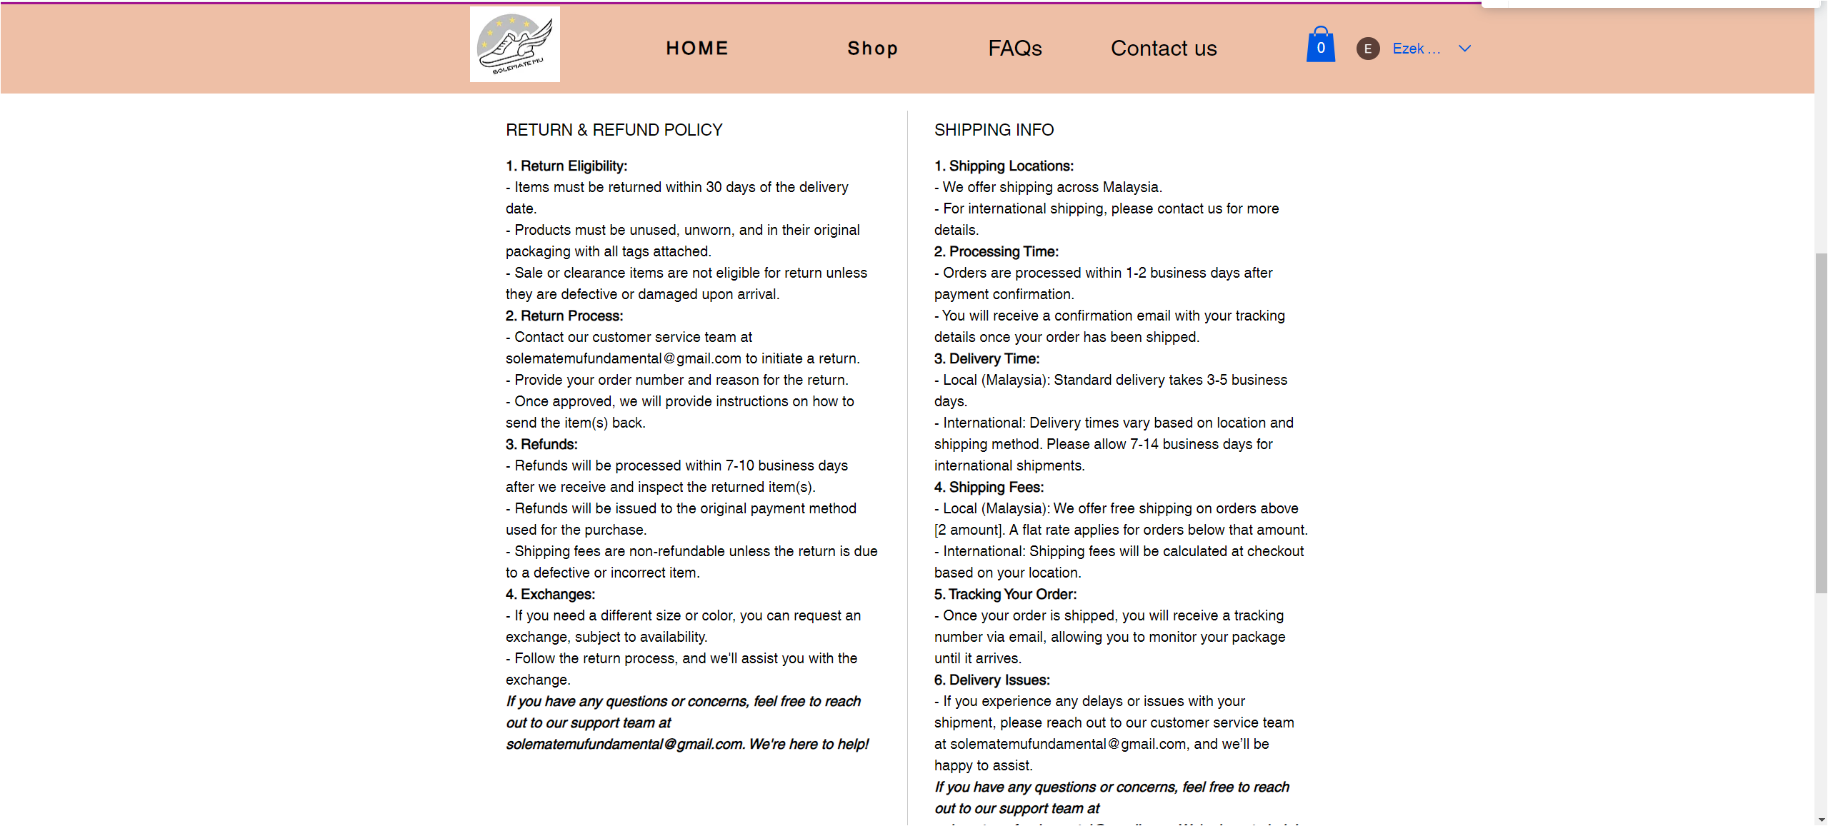

Figure 17: The second part of the AJ1 HIGH OG NAVY product page

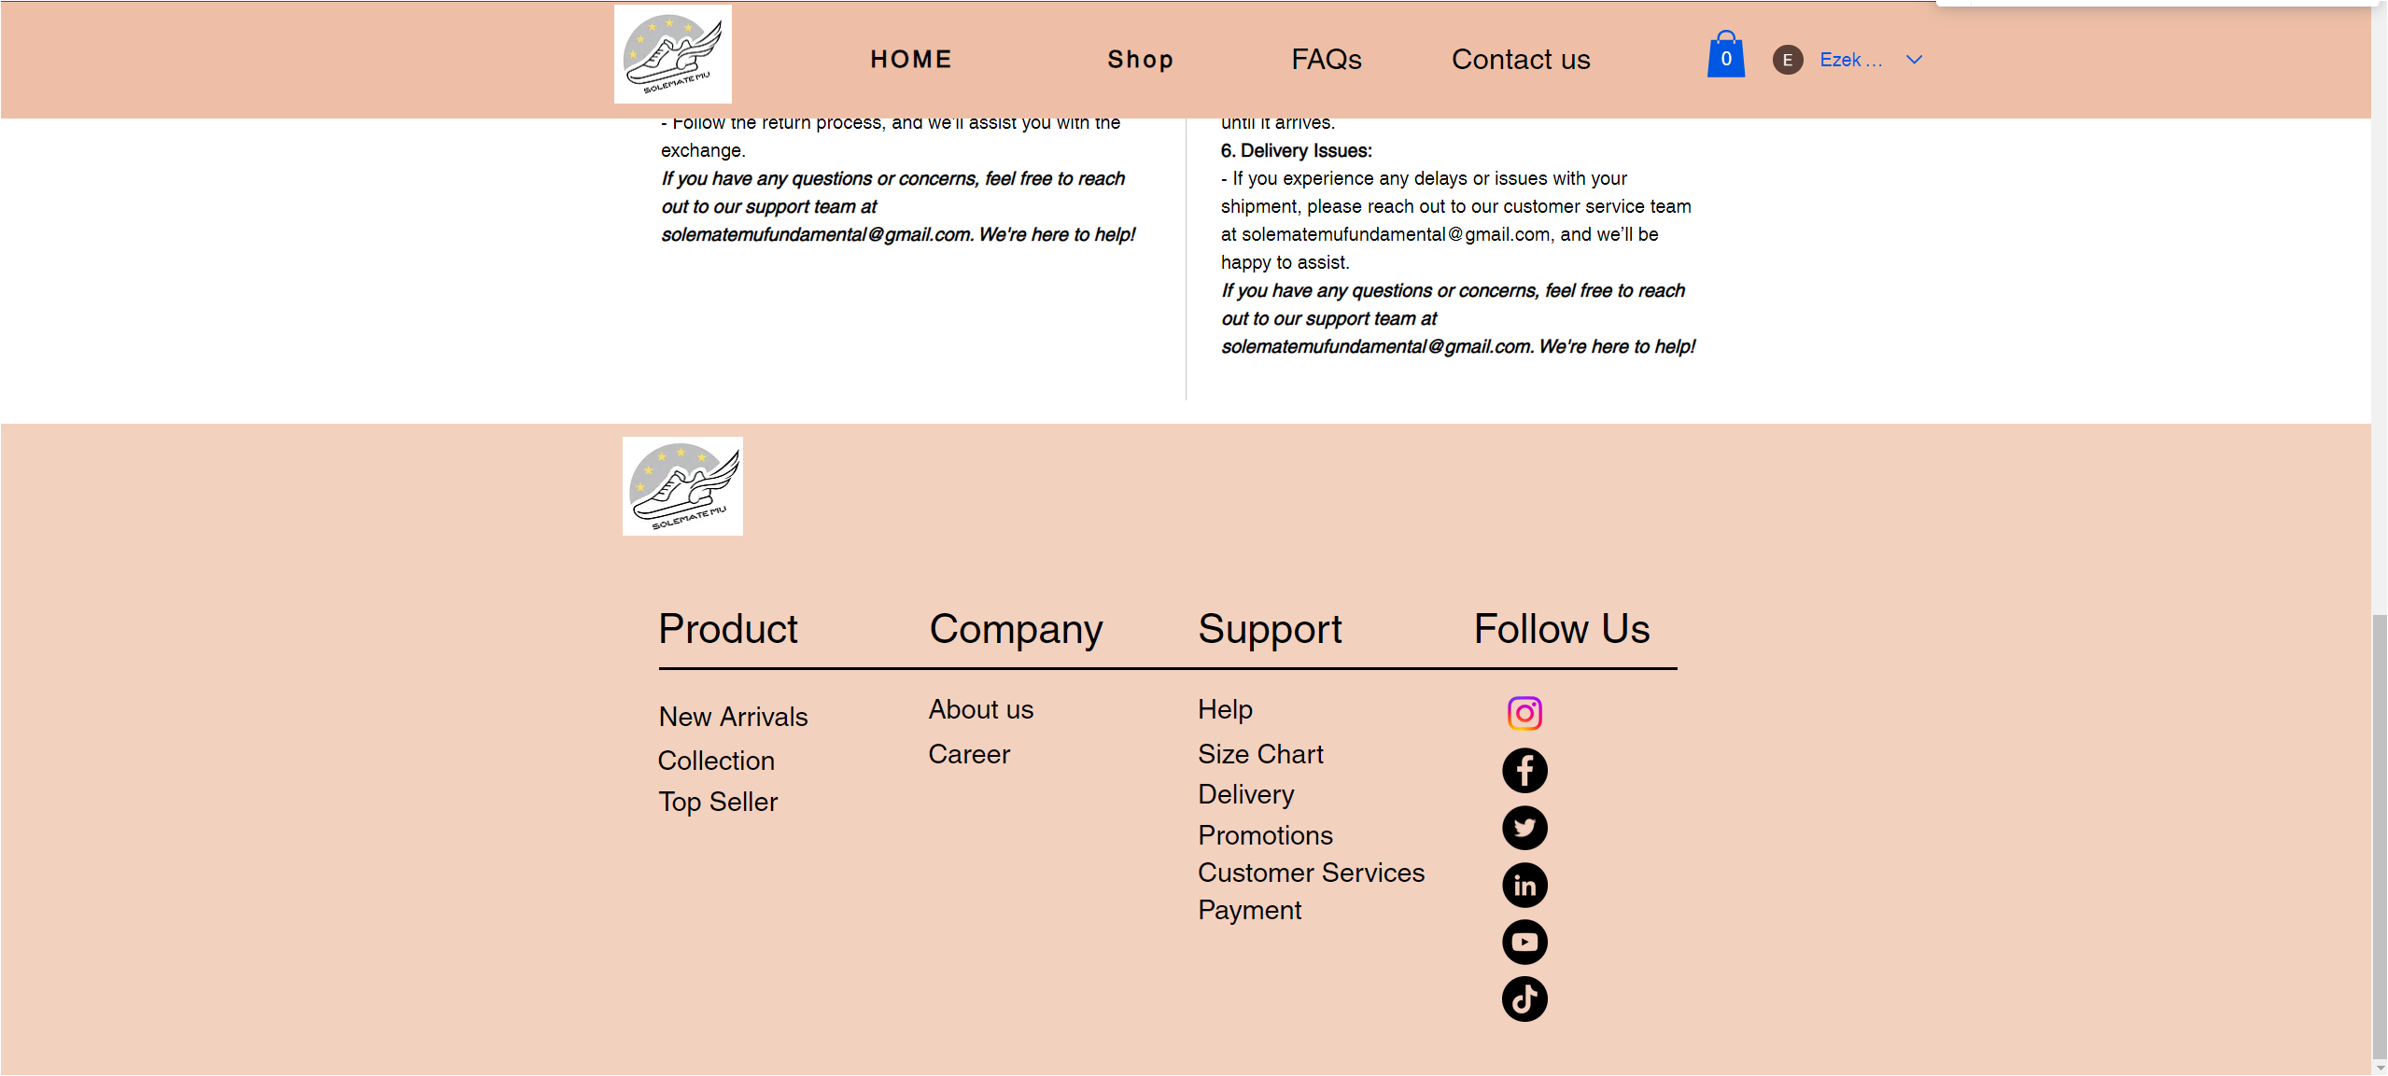

Figure 18: The last part of the AJ1 HIGH OG NAVY product page

**User Manual:**



Figure 19: Cover page of user manual

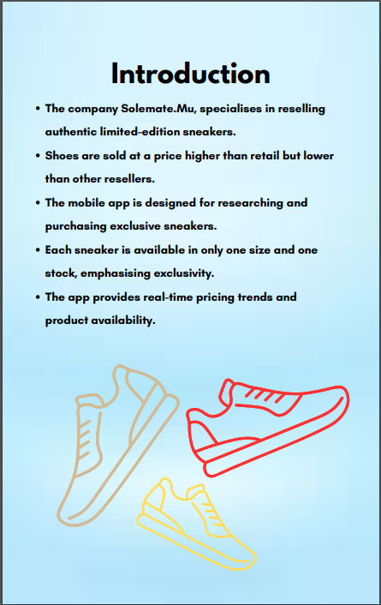

Figure 20: Introduction of the company

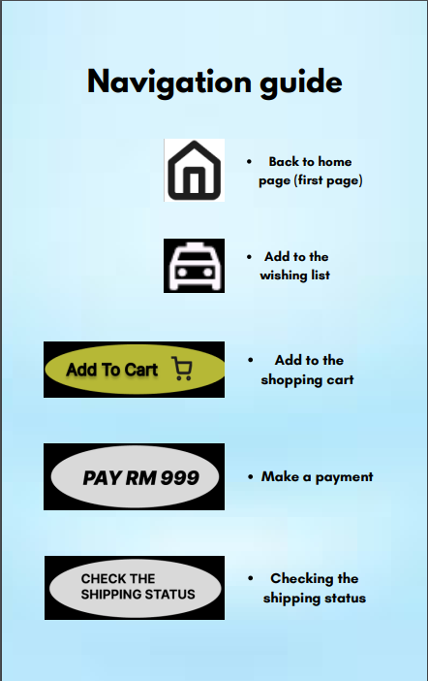

Figure 21: Navigation guide page of user manual

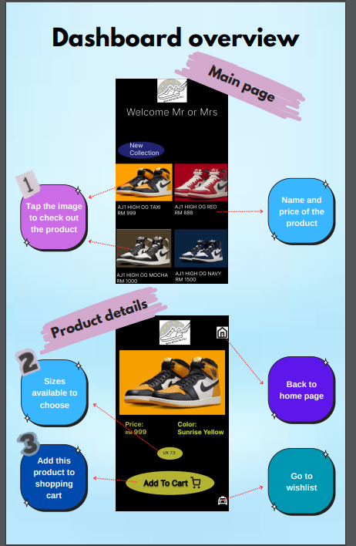

Figure 22: Dashboard overview 1

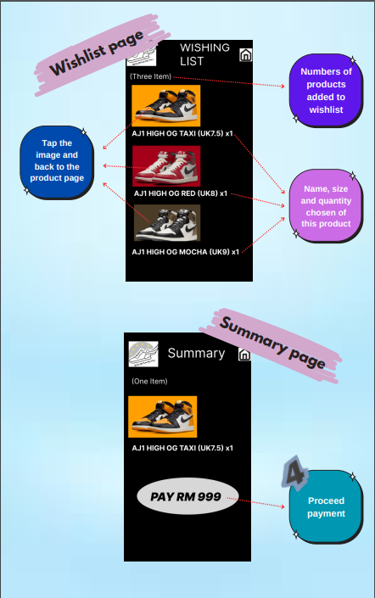

Figure 23: Dashboard overview 2

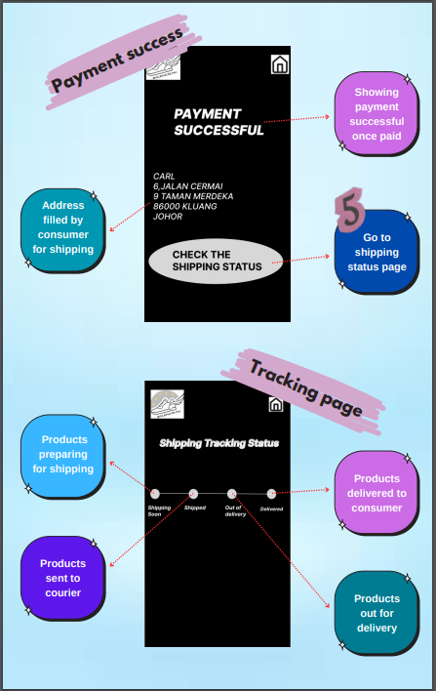

Figure 24: Dashboard overview 3

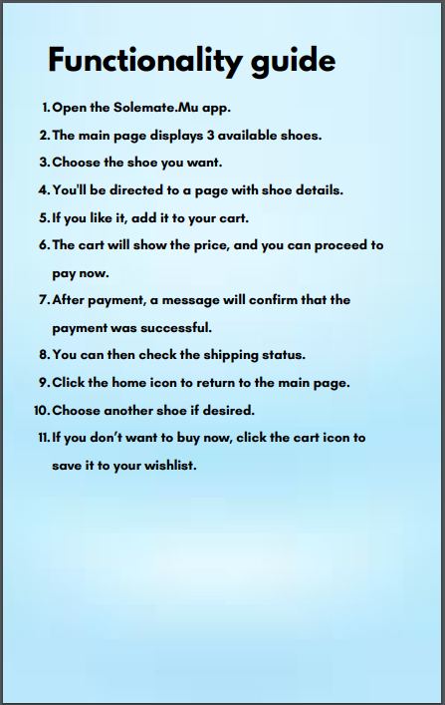

Figure 25: Functionality guide page



Figure 26: Visual design and branding page

Figma

<https://www.figma.com/design/xkLQuSzxbJ04JBXSRHZaKI/Figma-basics?node-id=1669-162202&node-type=canvas&t=32EaFaFHiWvChi5j-0>

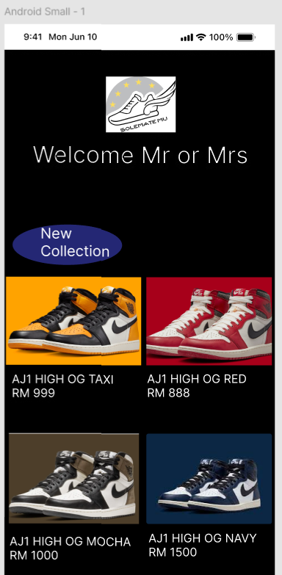

Figure 1: The main page of the mobile app

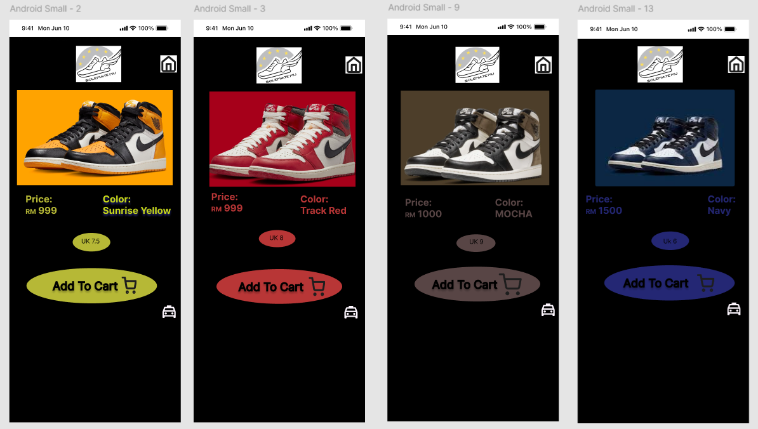

Figure 2: The product page will be show when user click on each of the product in the main page to view

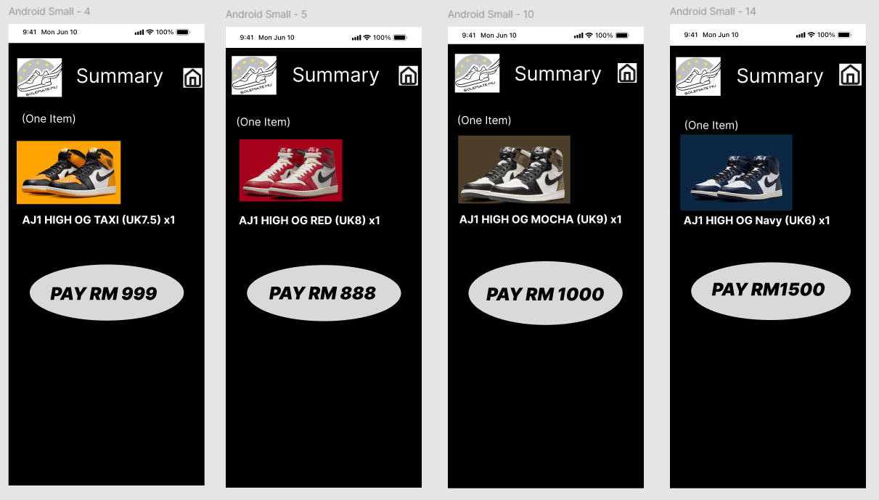

Figure 3: The amount of each product will be show when user click on add to cart

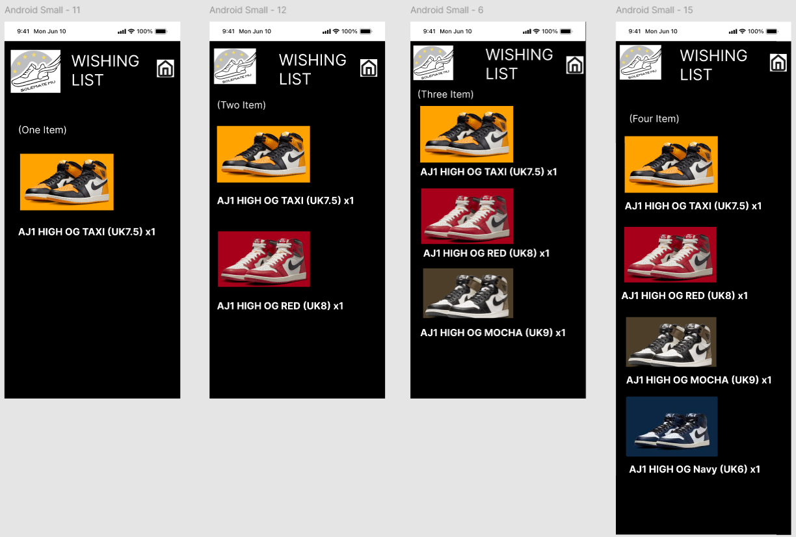

Figure 4: The wishing list of the user when click on the taxi symbol

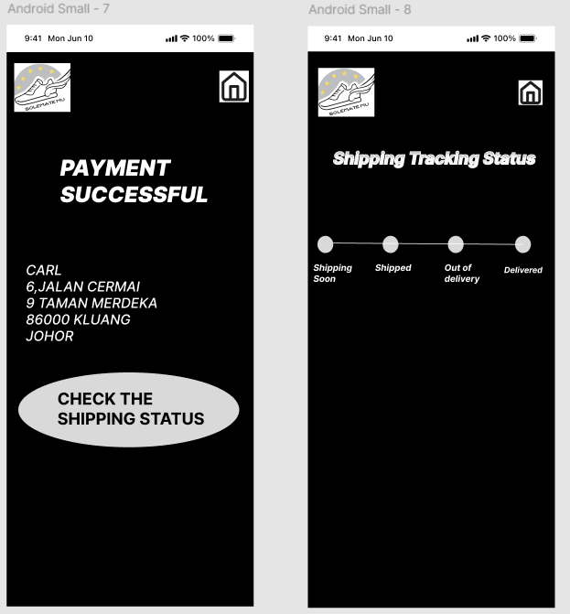

Figure 5: The payment successful and the shipping tracking status when user purchase the sneakers